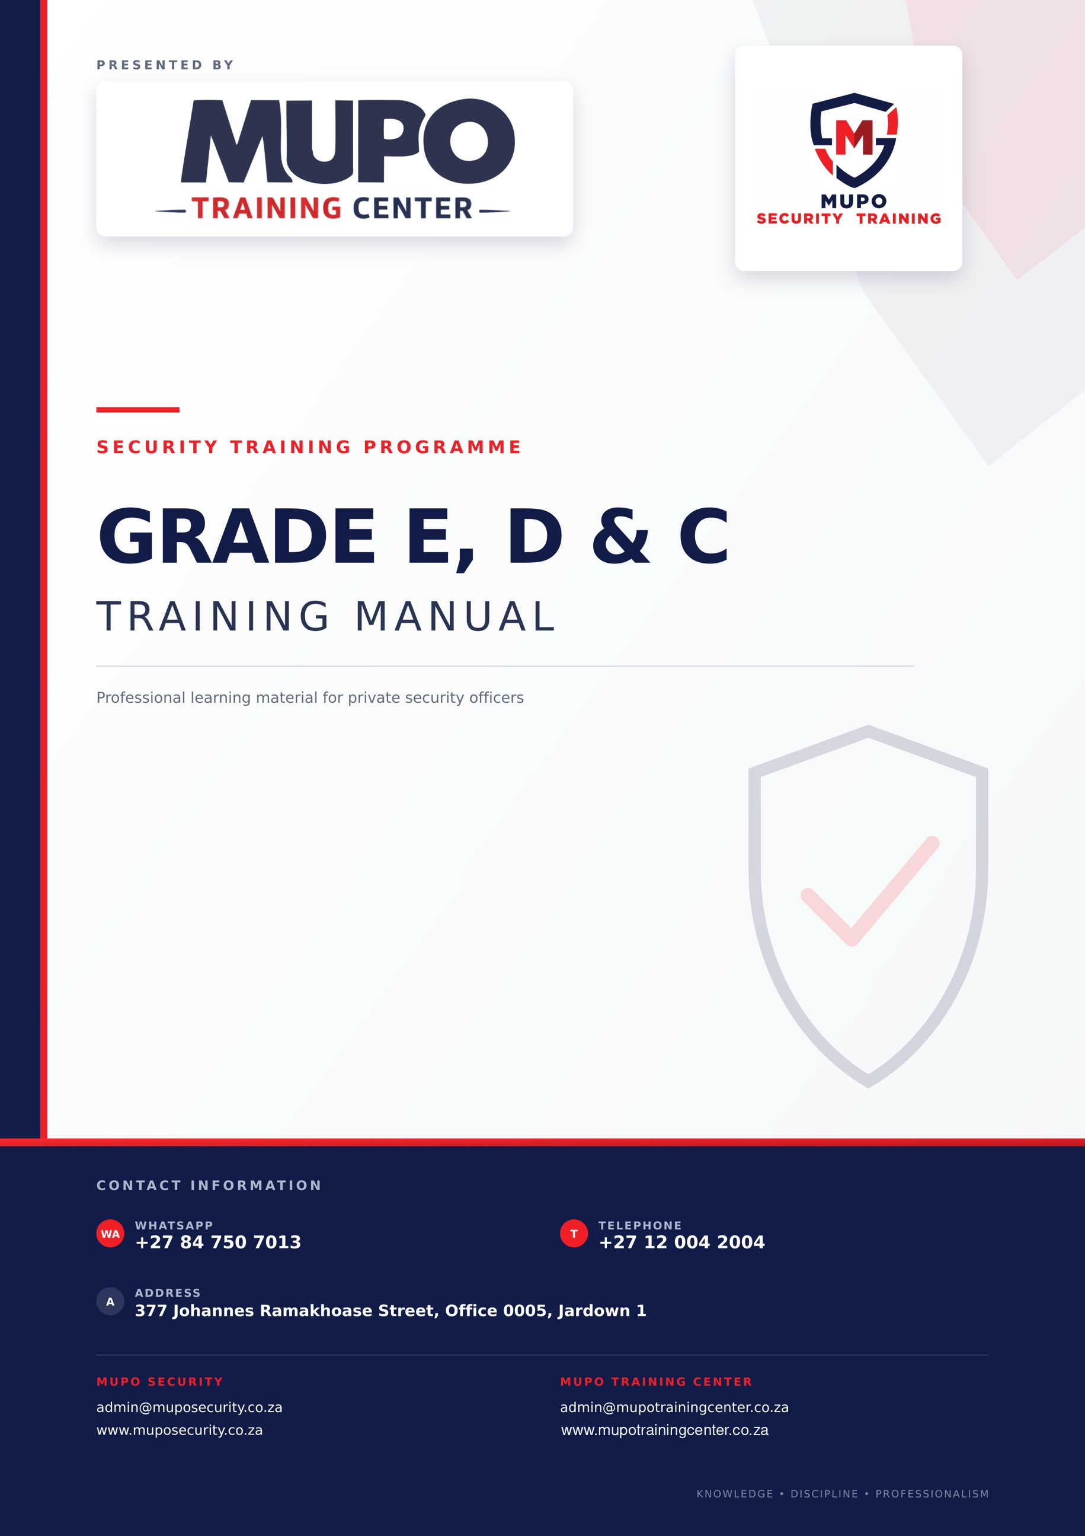

Table of Contents
COURSE INFORMATION AND LEARNER GUIDANCE 8
PURPOSE AND SCOPE 8
HOW TO USE THIS MANUAL 8
COURSE STRUCTURE AND ESTIMATED LEARNING TIME 8
PREREQUISITES 8
ASSESSMENT AND COMPLETION 8
SAFETY, EMERGENCY AND LEGAL NOTICE 9
LEARNER SUPPORT 9
1. MODULE 1: PERSONAL HYGIENE AND GENERAL APPEARANCE 10
MODULE 1 LEARNING OUTCOMES 10
1.1. PERSONAL HYGIENE 10
2. QUESTIONS AND ANSWERS 11
2.1 QUESTIONS: 11
2.2. ANSWERS: 11
3. MODULE 2: PUBLIC RELATIONS 12
MODULE 2 LEARNING OUTCOMES 12
3.1. ADDRESSING THE GENERAL PUBLIC 12
3.2. ADDRESSING THE CLIENT REPRESENTATIVE 12
3.3. FAVOURABLE IMPRESSIONS 12
3.4. POINTS THAT CONTRIBUTE TO POOR RELATIONS WITH THE GENERAL PUBLIC 13
4. QUESTIONS AND ANSWERS: 13
4.1. QUESTIONS: 13
4.2. ANSWERS 13
5. MODULE 3: ROLE AND FUNCTION OF SECURITY 14
MODULE 3 LEARNING OUTCOMES 14
5.1 SECURITY FUNCTION 14
5.2 THE AIM OF SECURITY 14
5.3 PRINCIPLES OF SECURITY 14
5.4 CONTRIBUTION OF THE SECURITY PERSONNEL 15
5.5 VULNERABLE AREAS AND VITAL POINTS 15
6. QUESTIONS AND ANSWERS: 15
6.1 QUESTIONS: 15
6.2 ANSWERS: 15
7. MODULE 4: RECOGNITION OF BOMBS, EXPLOSIVE DEVICES AND FIREARMS 17
MODULE 4 LEARNING OUTCOMES 17
7.1 DIFFERENT FIREARMS 17
7.2 DIFFERENT GROUPS OF FIREARMS: 17
7.3 TYPES OF BOMBS: 17
7.4 EXAMPLES OF MILITARY BOMBS 18
7.5 TARGETS OF TERRORISTS: 18
7.6 IMMEDIATE ACTION DRILLS ON DISCOVERING THE BOMB: 18
7.7 SUSPICIOUS-OBJECT RESPONSE AND AREA CONTROL 18
7.8 IMMEDIATE ACTION DRILLS AFTER AN EXPLOSION: 19
7.9 PURPOSE OF THE APPLICATION OF THE BOMB: 19
7.10 BOMB-THREAT CALL-TAKING PROCEDURE 19
7.11 BOMB SEARCH 19
7.12 IMMEDIATE ACTIONS AFTER A BOMB-THREAT CALL 20
7.13 MODULE 4 KNOWLEDGE CHECK AND PRACTICAL ACTIVITY 20
8. MODULE 5: DISCIPLINE AND PROFESSIONAL CONDUCT 21
MODULE 5 LEARNING OUTCOMES 21
8.1 MEANING AND PURPOSE OF DISCIPLINE 21
8.2 PROFESSIONAL STANDARDS 21
8.3 LAWFUL INSTRUCTIONS AND REPORTING LINES 21
8.4 ATTENDANCE, HANDOVER AND RECORDKEEPING 21
8.5 CORRECTIVE DISCIPLINE AND GRIEVANCES 22
8.6 MODULE 5 KNOWLEDGE CHECK AND PRACTICAL ACTIVITY 22
9. MODULE 6: BASIC SELF-DEFENCE AND PERSONAL SAFETY 23
MODULE 6 LEARNING OUTCOMES 23
9.1 SAFETY-FIRST PRINCIPLE 23
9.2 SITUATIONAL AWARENESS 23
9.3 VERBAL DE-ESCALATION 23
9.4 LAWFUL AND PROPORTIONATE RESPONSE 23
9.5 ACTIONS AFTER AN INCIDENT 23
9.6 MODULE 6 KNOWLEDGE CHECK AND PRACTICAL ACTIVITY 24
10. MODULE 7: OBSERVATION 25
MODULE 7 LEARNING OUTCOMES 25
10.1 THE AIMS OF OBSERVATION 25
10.2 OBSERVATION SHOULD BE TACKLED SYSTEMATICALLY 25
10.3 OBJECTS WHICH HAMPER OBJECTIVE OBSERVATION 25
10.4 SENSES USED DURING OBSERVATION 25
10.5 OBSERVATION OF PEOPLE 26
10.6 OBSERVATION OF VEHICLES 26
10.7 OBSERVATION OF AN OBJECT 26
10.8 MODULE 7 KNOWLEDGE CHECK AND PRACTICAL ACTIVITY 27
11. MODULE 8: GUARDING AND PATROLLING 28
MODULE 8 LEARNING OUTCOMES 28
11.1. AIM OF PATROLLING: 28
11.2 SECURITY RISKS 28
11.3 GENERAL PROCEDURE IN AN EMERGENCY 29
11.4 CIRCUMSTANCES UNDER WHICH THE ALARM SHOULD BE RAISED 29
11.5 EQUIPMENT OF THE GUARD 29
11.6 PHYSICAL BARRIERS 29
11.7 LOCATION OF EMERGENCY EQUIPMENT 30
11.8 PRINCIPLES ON PERFORMING PATROLS 30
11.9 CONCEALMENT SITES: 30
11.10 MODULE 8 KNOWLEDGE CHECK AND PRACTICAL ACTIVITY 31
12. MODULE 9: FIREFIGHTING, PREVENTION AND PROTECTION 32
MODULE 9 LEARNING OUTCOMES 32
12.1 SAFETY PRECAUTIONS BEFORE USING A FIRE EXTINGUISHER 32
12.2 LOCATION OF FIREFIGHTING EQUIPMENT AND FIRE ALARMS: 33
12.3 ELEMENTS OF FIRE: 33
12.4 FIREFIGHTING DOS AND DON'TS 33
12.5 ELEMENTARY METHODS OF STARVING A FIRE: 34
12.6 CLASSIFICATION OF FIRE: 34
12.7 COMMON FIRE RISKS AND HAZARDS 34
12.8 EXPOSURES: 35
12.9 TYPICAL CARELESS ACTIONS: 35
12.10 IMMEDIATE ACTION DRILLS IN THE EVENT OF FIRE: 35
12.11 POSSIBLE RESULTING LOSS: 35
12.12 TYPES OF FIRE EXTINGUISHERS: 35
12.13 GOOD HOUSEKEEPING: 36
12.14 MODULE 9 KNOWLEDGE CHECK AND PRACTICAL ACTIVITY 36
13. MODULE 10: RADIO AND TELEPHONE COMMUNICATION 37
MODULE 10 LEARNING OUTCOMES 37
13.1 TELEPHONE: PRINCIPLES OF TELEPHONE PROCEDURE: 37
13.2 HOW TO RECEIVE AND CONVEY A TELEPHONE MESSAGE: 38
13.3 CARE AND HANDLING OF THE RADIO: 38
13.4 DOS AND DON'TS 38
13.5 PRINCIPLES OF THE RADIO PROCEDURE 38
13.6 COMMON WORDS AND PHRASES 39
13.7 MODULE 10 KNOWLEDGE CHECK AND PRACTICAL ACTIVITY 39
14. MODULE 11: LEGAL ASPECTS 40
MODULE 11 LEARNING OUTCOMES 40
14.1 PSIRA REGISTRATION OBLIGATIONS AND REQUIREMENTS (SECTIONS 20-23) 40
14.2 REGISTRATION ELIGIBILITY AND REFUSAL CONSIDERATIONS (SECTION 23) 40
14.3 SUSPENSION, WITHDRAWAL AND LAPSING OF REGISTRATION (SECTION 26) 41
14.4 CRIMINAL PROCEDURE ACT 51/1977 41
14.5 ARREST BY A PRIVATE PERSON WITHOUT A WARRANT (SECTION 42) 41
14.6 USE OF FORCE IN EFFECTING AN ARREST (SECTION 49) 41
14.7 PROCEDURE AFTER ARREST (SECTION 50) 42
14.8 SCHEDULE 1 OFFENCES 42
14.9 NATIONAL ROAD TRAFFIC ACT 93 OF 1996: UNAUTHORISED ACTS (SECTION 66) 42
14.10 PROPERTY REMOVAL WITHOUT CONSENT (GENERAL LAW AMENDMENT ACT 50 OF 1956) 43
14.11 FAILURE TO ACCOUNT FOR SUSPECTED STOLEN GOODS (GENERAL LAW AMENDMENT ACT 62 OF 1955) 43
14.12 CRIMINAL LAW 43
14.13 PRIVATE DEFENCE 43
14.14 CONSENT-BASED SEARCHES 44
14.15 MODULE 11 KNOWLEDGE CHECK AND PRACTICAL ACTIVITY 44
15. MODULE 12: INDUSTRIAL RELATIONS 45
MODULE 12 LEARNING OUTCOMES 45
15.1 DISCIPLINARY CODES 45
15.2 GRIEVANCE PROCEDURE 45
15.3 MODULE 12 KNOWLEDGE CHECK AND PRACTICAL ACTIVITY 46
16. MODULE 13: OCCUPATIONAL SAFETY 47
MODULE 13 LEARNING OUTCOMES 47
16.1 SYMBOLIC SAFETY SIGNS: 47
16.2 DANGERS OF SMOKING IN A NON-SMOKING ZONE 47
16.3 CAUSES OF AN ACCIDENT: 48
16.4 UNSAFE ACTS 48
16.5 UNSAFE CONDITIONS 48
16.6 EXAMPLES OF UNSAFE ACTS AND CONDITIONS WHEN LOADING OR OFFLOADING A TRUCK: 48
16.7 EXAMPLES OF POOR HOUSEKEEPING 48
16.8 REPORT UNSAFE ACTS AND CONDITIONS 49
16.9 MODULE 13 KNOWLEDGE CHECK AND PRACTICAL ACTIVITY 49
17. MODULE 14: ACCESS CONTROL 50
MODULE 14 LEARNING OUTCOMES 50
17.1 DEFINITION OF ACCESS CONTROL: 50
17.2 REASONS FOR ACCESS CONTROL: 50
17.3 FUNCTIONS AT ACCESS CONTROL 50
17.4 THE 3 “D” PRINCIPLE 50
17.5 SECURITY KNOWLEDGE 51
17.6 AIDS EFFECTIVE IN ACCESS CONTROL 51
17.7 ACCESS CONTROL PROCEDURES 51
17.8 MODULE 14 KNOWLEDGE CHECK AND PRACTICAL ACTIVITY 52
18. MODULE 15: SEARCH PROCEDURES AND TECHNIQUES 53
MODULE 15 LEARNING OUTCOMES 53
18.1 THE GOLDEN RULE OF SEARCHING: 53
18.2 WHAT TO LOOK FOR DURING THE SEARCH: 54
18.3 SEARCHING THE VEHICLE 54
18.4 PLACES TO SEARCH: 54
18.5 PROCEDURES IN DOING ROUTINE CHECKS: 55
18.6 PROCEDURE FOR SELECTING COMPANY EMPLOYEES TO BE SEARCHED: 55
18.7 AREAS TO BE COVERED DURING SEARCHING: 56
18.8 SEARCHING OF BRIEFCASE, PARCELS OR CONTAINERS: 56
18.9 MODULE 15 KNOWLEDGE CHECK AND PRACTICAL ACTIVITY 56
19. MODULE 16: POCKETBOOKS AND THE OCCURRENCE BOOK 57
MODULE 16 LEARNING OUTCOMES 57
19.1 REASONS FOR KEEPING THE POCKET BOOK 57
19.2 AS EVIDENCE IN COURT: 57
19.3 REQUIREMENTS FOR KEEPING THE POCKET BOOK: 57
19.4 MODULE 16 KNOWLEDGE CHECK AND PRACTICAL ACTIVITY 58
20. MODULE 17: WRITTEN REPORTS 59
MODULE 17 LEARNING OUTCOMES 59
20.1 REQUIREMENTS FOR AN EFFECTIVE REPORT: 59
20.2 CONTENT OF THE REPORT: 59
20.3 FORM OF THE REPORT: 59
20.4 MODULE 17 KNOWLEDGE CHECK AND PRACTICAL ACTIVITY 60
21. MODULE 18: THE THREAT 61
MODULE 18 LEARNING OUTCOMES 61
21.1 DEFINITION OF THE THREAT: 61
21.2 TYPES OF THREATS 61
21.3 INTERNAL THREATS: 61
21.4 EXTERNAL THREATS: 61
21.5 INTERNAL AND EXTERNAL THREATS: 62
21.6 THREATS AGAINST SECURITY OFFICERS 62
21.7 THREATS AGAINST INSTALLATION 62
21.8 COUNTERMEASURES AGAINST THREATS: 62
21.9 MODULE 18 KNOWLEDGE CHECK AND PRACTICAL ACTIVITY 63
APPENDIX A: KNOWLEDGE-CHECK RECORD 64
APPENDIX B: GLOSSARY 65
APPENDIX C: REFERENCES AND VERSION CONTROL 66
Primary references 66
Revision record 66
APPENDIX D: LEARNER COMPLETION AND SIGN-OFF 67

COURSE INFORMATION AND LEARNER GUIDANCE

PURPOSE AND SCOPE
This combined Grade E, D and C training manual supports facilitator-led classroom delivery, independent revision and structured online learning. It must be used by an appropriately authorised training provider together with current PSiRA requirements, approved assessments and site-specific procedures.

HOW TO USE THIS MANUAL
Print edition: work through the modules in order, complete the knowledge checks in writing, record results in Appendix A and use Appendix D for final sign-off.
Online edition: present each module as a separate learning unit, keep the table-of-contents links, convert knowledge checks into LMS activities, provide immediate feedback and retain electronic completion records.

COURSE STRUCTURE AND ESTIMATED LEARNING TIME
The manual contains 18 modules with approximately 32 hours of suggested learning time, including theory, discussion, scenarios, practice and formative assessment. The training provider must adjust delivery time to learner needs and any current accredited programme requirements.

PREREQUISITES
- The learner must be enrolled through an authorised training process and meet the provider's identity, language, prior-learning and attendance requirements.
- The learner must have access to a facilitator or support contact for legal, emergency and practical questions.
- Practical activities require a safe venue, appropriate supervision and the necessary site or training equipment.

ASSESSMENT AND COMPLETION
- Complete every module, knowledge check and assigned practical activity.
- Use the current provider-approved pass mark and assessment instrument. Where no approved formative benchmark is specified, 70% is suggested for self-check activities.
- A qualified facilitator or assessor must evaluate practical competence; reading the manual alone does not demonstrate practical competence.
- Final assessment, moderation, attendance and certification must follow current PSiRA and accredited-provider requirements.

SAFETY, EMERGENCY AND LEGAL NOTICE
This manual provides general training guidance and is not legal advice or a substitute for current legislation, emergency-service instructions, post orders or accredited practical instruction. In an emergency, protect life, raise the alarm, follow the site plan and contact the appropriate emergency service. Do not handle firearms, suspicious objects, hazardous substances or fire equipment unless authorised, trained and it is safe to do so.

LEARNER SUPPORT
Telephone: +27 12 004 2004 | WhatsApp: +27 84 750 7013 | Address: 377 Johannes Ramakhoase Street, Office 0005, Jardown 1
Email: admin@muposecurity.co.za | admin@mupotrainingcenter.co.za
Web: www.muposecurity.co.za | www.mupotrainingcenter.co.za

1. MODULE 1: PERSONAL HYGIENE AND GENERAL APPEARANCE
AIM The aim is to stress the importance of the prevention and control of diseases among members and individuals of the work force.
Suggested learning time: 60 minutes.

MODULE 1 LEARNING OUTCOMES
After completing this module, the learner should be able to:
- Apply personal-hygiene practices appropriate to security work.
- Explain how grooming and uniform standards affect health and professionalism.
- Identify hygiene practices that reduce illness and contamination risks.
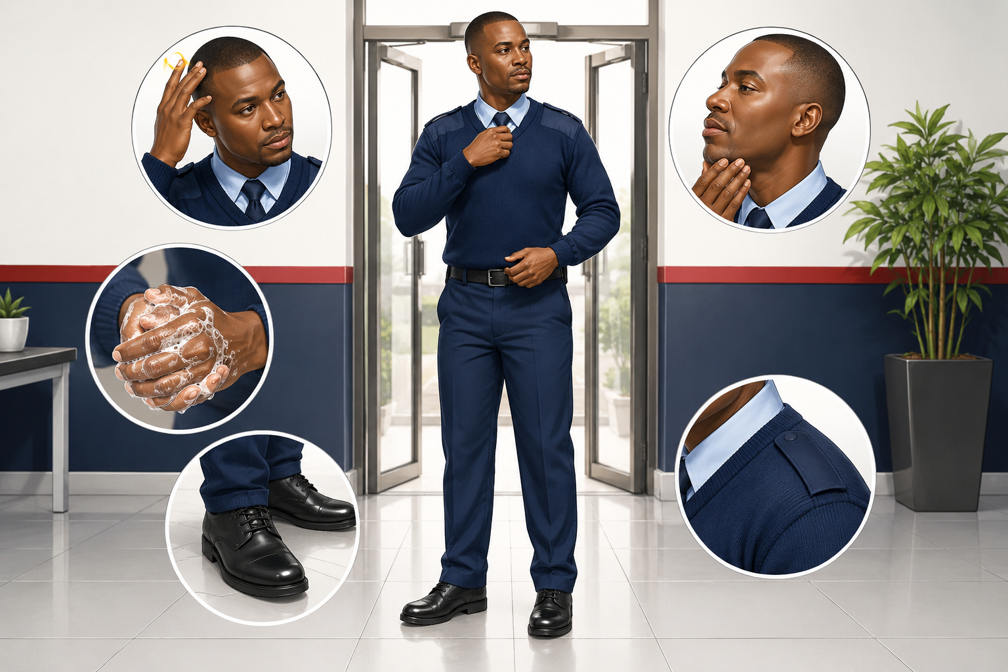
Training focus | Professional hygiene and appearance

1.1. PERSONAL HYGIENE
This includes the health rules that a person should follow in order to remain fit and healthy.
1.1.1. Personal cleanliness: the aim is absolute cleanliness.
1.1.2. Skin: Bathe daily, paying particular attention to the parts of the body that perspire.
1.1.3. Hands: Hands should be washed before meals and before handling food.
1.1.4. Nails: nails should be kept short and clean.
1.1.5. Care of feet: Feet must be kept clean at all times. Clean socks must be put on every day; otherwise, your feet may become inflamed and smelly.
1.1.6. Care of teeth: Teeth should be brushed at least twice a day.
1.1.7. Head: Hair should be kept short and clean.
1.1.8. Clothing: Wear clean clothes every day. Dirty and smelly clothes are unpleasant and unhealthy.
1.1.9. Mind and habits: A clean mind and clean thoughts are essential if you want to keep yourself fit.
1.1.10. Smoking: It is harmful, particularly for people undergoing training. Do not discard cigarette butts carelessly.
1.1.11. Socks: Woolen socks are the best as they are porous and allow fresh air to reach the skin.
1.1.12. Fresh air: The spread of infection through breathing and sneezing is called droplet infection and can be prevented by avoiding overcrowding and ensuring good ventilation.
1.1.13. Food and food care: Absolute cleanliness is required when preparing, cooking and serving food. Keep flies away.
1.1.14. Spitting: It is a filthy habit and should be avoided.
1.1.15. Exercise: Exercising the voluntary muscles is important for our health and may take the form of working, walking, climbing or running.
1.1.16. Rest: A period of rest should follow continuous work involving any part of the body.
1.1.17. Sleep: This is the only form of complete rest for the whole body and restores both mental and physical well-being.

2. QUESTIONS AND ANSWERS

2.1 QUESTIONS:
2.1.1. Why is it necessary for a security officer to be hygiene-conscious?
2.1.2. Why do we wear clean clothes every day?

2.2. ANSWERS:
2.2.1. To keep fit and healthy.
2.2.2. Dirty clothing is smelly and unhealthy.

3. MODULE 2: PUBLIC RELATIONS
AIM The aim of this module is to give you a broad understanding of the meaning of the term public relations and the need for the promotion of good public relations.
Suggested learning time: 90 minutes.

MODULE 2 LEARNING OUTCOMES
After completing this module, the learner should be able to:
- Communicate respectfully with the public and client representatives.
- Demonstrate conduct that creates a professional impression.
- Identify behaviours that damage public and client relations.

3.1. ADDRESSING THE GENERAL PUBLIC
A security officer is often the first person seen by anyone entering the premises. If the officer is SLOPPY, DIRTY OR WEARING AN INCOMPLETE UNIFORM, the first impression of the company will be poor.
To ensure that he portrays a good image of himself and the company, he must always be clean and neat, friendly and helpful, and familiar with his job and responsibilities.

3.2. ADDRESSING THE CLIENT REPRESENTATIVE
To portray and maintain a positive image with clients, the following must be done:
- BE HELPFUL: This is what all visitors and fellow employees expect from security personnel.
- COURTESY: It helps public relations run smoothly.
- FRIENDLINESS: A smile costs nothing. It gives a green light to good communication and makes future contact easier.
- DIGNITY: Never consider yourself better than your client. When addressing clients: a. Stand up straight.
- b. Use a controlled voice.
- c. Use proper language.

3.3. FAVOURABLE IMPRESSIONS
A favourable impression is maintained through consistent conduct after the initial greeting. Apply the following standards throughout every interaction:
- BE SMARTLY DRESSED: Wear your uniform in full every day.
- HAVE A PROFESSIONAL ATTITUDE: Be tactful and enforce the rules and regulations of the company. Act diplomatically.
- COMMUNICATE EFFECTIVELY: Do not use slang, and address visitors with respect.
- SHOW CONCERN: Help people with their problems and listen to their complaints.
- DEMONSTRATE GOOD MANNERS: Always greet people politely.

3.4. POINTS THAT CONTRIBUTE TO POOR RELATIONS WITH THE GENERAL PUBLIC
Public relations is the image we portray of ourselves and the company. It is largely your responsibility to create and maintain good public relations. The following is a list of traits that a security officer must avoid at all costs:
- POOR ATTITUDE
- CRUDE SPEECH
- INCOMPETENCE
- RUMOUR SPREADING
- DISINTEREST
- IMPOLITENESS
- EXPLOITATION
- ABUSE OF AUTHORITY
- POOR COMMUNICATION

4. QUESTIONS AND ANSWERS:

4.1. QUESTIONS:
4.1.1. List five points that create a favourable impression when dealing with the public.
4.1.2. List five points that contribute to poor public relations.
4.1.3. List three things that a security officer must remember when addressing a client.

4.2. ANSWERS
4.2.1. Be smartly dressed, have a professional attitude, communicate effectively, show concern, and have good manners.
4.2.2. Poor attitude, crude speech, incompetence, impoliteness and poor communication.
4.2.3. Helpfulness, courtesy, friendliness and dignity.

5. MODULE 3: ROLE AND FUNCTION OF SECURITY
AIM The aim of this module is to ensure that you understand the role and principles of security within an organisation.
Suggested learning time: 90 minutes.

MODULE 3 LEARNING OUTCOMES
After completing this module, the learner should be able to:
- Explain the role and core functions of security personnel.
- Distinguish vulnerable areas from vital points.
- Apply the main principles of security to routine duties.

5.1 SECURITY FUNCTION
Security functions are divided into:
SECURITY OF INFORMATION:
- SECURITY OF MATERIAL AND ASSETS
- SECURITY OF PERSONNEL

5.2 THE AIM OF SECURITY
Security is our defence against enemy activities; therefore, the aim of security is based on the principles that:
- Sabotage does not take place.
- Terrorist action fails.
- Classified information does not fall into the wrong hands.
- The undermining, subversive and propaganda efforts of the enemy shall not succeed.
- Enemy action is prevented from breaking through the security system.
- Investigations are facilitated through the SAPS.
- All concerned are made security-conscious.

5.3 PRINCIPLES OF SECURITY
SECURITY PRINCIPLES MUST:
- Embrace all persons who have access to all premises.
- Be designed so that they can detect people who endanger the security of classified information.
- Prevent access to classified information.
- Be based on the principle that classified information is made known only to those who need to know it.

5.4 CONTRIBUTION OF THE SECURITY PERSONNEL
Security personnel must realize that they have an important contribution to make.
They should go out of their way:
- Not to discriminate on the basis of colour or race.
- To identify basic grievances among workers, such as food, housing, transport and health services.
- To recognize traps set by the enemy and not to react by unacceptable methods.

5.5 VULNERABLE AREAS AND VITAL POINTS
Every factory or company has vital or vulnerable areas. Vulnerable areas are those that, because of their location, make detection difficult and penetration easy.
VULNERABLE AREAS:
- Damaged doors, windows and fences.
- Areas with poor illumination.
- Drainage pipes and manholes.
- Trees and buildings next to the fence.
- Vital points are specific places in a factory or company that, because of their importance, are essential to the company.
VITAL POINTS:
- Computer rooms.
- Electricity supply.
- Safes.
- Water reservoirs.
- Petrol pumps.
- Gas supply.

6. QUESTIONS AND ANSWERS:

6.1 QUESTIONS:
6.1.1 List the three categories into which security is divided.
6.1.2 Name three principles on which the aim of security is based.
6.1.3 List the important contribution that a security officer can make.

6.2 ANSWERS:
6.2.1 Security of information.
6.2.2 Security of material and assets.
6.2.3 Security of personnel.
6.2.4. Sabotage does not take place.
6.2.5. Terrorist action fails.
6.2.6. No classified information falls into the wrong hands.
6.2.7 Not to be discriminatory.
6.2.8 To identify and report basic grievances.
6.2.9 To recognize traps.

7. MODULE 4: RECOGNITION OF BOMBS, EXPLOSIVE DEVICES AND FIREARMS
AIM The aim of this module is to introduce you to the most commonly used bombs, explosive devices and firearms, and to explain what action you should take in the event of a bomb explosion.
Suggested learning time: 120 minutes.

MODULE 4 LEARNING OUTCOMES
After completing this module, the learner should be able to:
- Recognise common firearm, explosive-device and bomb-threat indicators.
- Apply safe notification, isolation and evacuation actions.
- Record and report bomb-threat information without handling suspicious objects.

7.1 DIFFERENT FIREARMS
Firearms used by adversaries can be stolen from private owners, military bases, SAPS, security officers or be smuggled into our country from neighbouring states.

7.2 DIFFERENT GROUPS OF FIREARMS:
AUTOMATIC AND SEMI-AUTOMATIC RIFLES:
- AK47, AKM, AND OTHER AK WEAPONS
- R4 AND R5, OR LM4 AND LM5
MACHINE PISTOLS:
- SCORPION
- UZI
PISTOLS:
- MAKAROV PISTOL
- TOKAREV PISTOL
- Z88
REVOLVERS:
- .45 MAGNUM
- .38 SPECIAL
SHOTGUNS:
- AUTOMATIC, SEMI-AUTOMATIC AND PUMP-ACTION

7.3 TYPES OF BOMBS:
There are basically two categories of bombs:
- Military and
- Home-made bombs

7.4 EXAMPLES OF MILITARY BOMBS
- Limpet mines
- Demolition charges
- Black widow
- TM 57 and TM 46 a.v. mines
- 200g and 400g T.N.T. blocks
- RGD-5 and F1 offensive hand grenades
HOME-MADE BOMBS:
- Molotov cocktail
- Letter/parcel bomb
- Briefcase bomb
- Vehicle bomb

7.5 TARGETS OF TERRORISTS:
- ESSENTIAL SERVICES - gas supplies and electrical substations
- OFFICIALDOM - courts and police stations
- HIGH-DENSITY POPULATION AREAS - shopping centres and sports complexes
- TRANSPORTATION LINKS - train stations and bus stops
- COMMUNICATION CENTRES - post offices, the SABC and fuel stations

7.6 IMMEDIATE ACTION DRILLS ON DISCOVERING THE BOMB:
- Do not panic or cause panic
- Notify the control room
- Mark the location of the bomb
- Safeguard the immediate area
- Do not touch or handle the bomb

7.7 SUSPICIOUS-OBJECT RESPONSE AND AREA CONTROL
If an unattended or suspicious object is discovered:
- Do not touch, move, open, cover or examine the object closely.
- Move people away and establish a safe exclusion area in accordance with the site emergency plan.
- Notify the supervisor, control point and emergency services through approved channels.
- Record the object's location, appearance and the time it was noticed from a safe position.
- Preserve access routes for emergency responders and prevent unauthorised entry.

7.8 IMMEDIATE ACTION DRILLS AFTER AN EXPLOSION:
- Do not panic or cause panic
- Notify the control room
- Activate the emergency procedures
- Secure the location
- Make notes.

7.9 PURPOSE OF THE APPLICATION OF THE BOMB:
- To set fire to premises
- To injure or kill persons
- To draw attention to political grievances
- As part of a psychological onslaught
- To draw attention away from planned incidents
- To disrupt essential services
- To occupy security personnel

7.10 BOMB-THREAT CALL-TAKING PROCEDURE
While the call is in progress, remain calm, listen carefully and record the caller's exact words. The receiver should:
- Keep the person talking as long as possible
- Listen carefully to the voice
Ask the person to repeat the message and note the following:
- What language does the person speak?
- Is the caller male or female?
- Does the voice sound like that of an adult or a child?
- Can you determine anything from the accent?
- Does the person speak clearly?
- Does the person use known phrases or slogans?
- Is there any noticeable speech interference?
- How serious does the person sound?
- Does the person sound nervous or anxious?

7.11 BOMB SEARCH
The layout of the threatened area will determine precisely how the search is carried out. Keep the following points in mind. Start 15-20 metres from the building and check the following areas outside the building:
- Manholes
- Culverts
- Piles of rubbish
- Rubbish bins
- Mailboxes
- Flowerpots
INSIDE THE BUILDING:
- Fire escapes
- Window and door ledges
- Air-conditioning units
- Ledges
- Window boxes
- Signs
- Gutters and overhangs

7.12 IMMEDIATE ACTIONS AFTER A BOMB-THREAT CALL
- Record the time the call ended and preserve all notes or electronic records.
- Notify the control point, supervisor and emergency services in accordance with the site emergency plan.
- Do not touch, move or interfere with any suspicious object.
- Do not use a radio or mobile phone close to a suspected device where the site emergency procedure prohibits it.
- Do not spread unverified information; communicate only through authorised channels.
- Assist with isolation, evacuation and access control only as directed.

7.13 MODULE 4 KNOWLEDGE CHECK AND PRACTICAL ACTIVITY
1. Knowledge question: State the first three actions after discovering a suspicious object.
2. Application question: What details should be recorded during a bomb-threat call?
3. Scenario activity: A bag with wires is found near an entrance. Explain your actions.
Expected response: do not touch it; isolate the area; notify the supervisor and emergency services under the site plan; record observations; support evacuation and access control.
Completion criterion: the learner's response must be accurate, lawful, site-appropriate and clearly communicated. Record the result in Appendix A.

8. MODULE 5: DISCIPLINE AND PROFESSIONAL CONDUCT
AIM The aim of this module is to develop reliable, ethical and disciplined conduct in the performance of security duties.
Suggested learning time: 60 minutes.

MODULE 5 LEARNING OUTCOMES
After completing this module, the learner should be able to:
- Explain discipline and professional conduct in security work.
- Follow lawful instructions, post orders and reporting lines.
- Respond appropriately to corrective action and workplace grievances.

8.1 MEANING AND PURPOSE OF DISCIPLINE
Discipline means consistent compliance with lawful instructions, post orders, workplace rules, professional standards and the PSiRA Code of Conduct. Its purpose is safe, reliable and accountable service.

8.2 PROFESSIONAL STANDARDS
- Report for duty on time, properly dressed and fit for duty.
- Remain alert and at the assigned post until properly relieved.
- Treat all people fairly, respectfully and without discrimination.
- Protect confidential information, property and official records.

8.3 LAWFUL INSTRUCTIONS AND REPORTING LINES
Follow lawful, clear and work-related instructions through the authorised chain of command. Seek clarification when an instruction is unclear. Do not follow an instruction that is manifestly unlawful; report the concern through the approved channel.

8.4 ATTENDANCE, HANDOVER AND RECORDKEEPING
Punctual attendance, complete handovers and accurate records maintain continuity and accountability. Absence, lateness, equipment defects and incomplete tasks must be reported promptly.

8.5 CORRECTIVE DISCIPLINE AND GRIEVANCES
Corrective action should be fair, consistent and based on workplace procedure. A learner or employee who believes they were treated unfairly should use the approved grievance or appeal process and avoid retaliation, argument or unauthorised disclosure.

8.6 MODULE 5 KNOWLEDGE CHECK AND PRACTICAL ACTIVITY
1. Knowledge question: What makes an instruction lawful and work-related?
2. Application question: Give three examples of disciplined conduct on duty.
3. Scenario activity: A supervisor corrects your late arrival. Describe the professional response.
Expected response: acknowledge the instruction or correction, remain respectful, follow the reporting line, correct the conduct and use the grievance procedure if necessary.
Completion criterion: the learner's response must be accurate, lawful, site-appropriate and clearly communicated. Record the result in Appendix A.

9. MODULE 6: BASIC SELF-DEFENCE AND PERSONAL SAFETY
AIM The aim of this module is to develop safe decision-making, awareness and de-escalation skills. Practical physical techniques may be taught only by a suitably qualified facilitator in a controlled environment.
Suggested learning time: 90 minutes.

MODULE 6 LEARNING OUTCOMES
After completing this module, the learner should be able to:
- Use awareness, distance and de-escalation as the first safety options.
- Explain that any force must be lawful, necessary and proportionate.
- Report and preserve information after a confrontation or use-of-force incident.

9.1 SAFETY-FIRST PRINCIPLE
The first objective is to avoid injury. Use awareness, safe positioning, distance, barriers, communication, withdrawal and assistance before considering physical action.

9.2 SITUATIONAL AWARENESS
- Observe hands, body language, escape routes, bystanders and possible weapons.
- Avoid becoming isolated or trapped and maintain access to communication.
- Call for assistance early when behaviour is escalating.

9.3 VERBAL DE-ESCALATION
Use a calm voice, simple instructions and respectful language. Acknowledge concerns without agreeing to unlawful demands. Do not threaten, insult, crowd or unnecessarily touch the person.

9.4 LAWFUL AND PROPORTIONATE RESPONSE
Any force must have a lawful basis and be reasonably necessary and proportionate to the immediate threat or authorised purpose. Stop using force when the lawful need ends and obtain medical assistance where required.

9.5 ACTIONS AFTER AN INCIDENT
- Make the area safe and request police or medical assistance when required.
- Notify the supervisor and preserve relevant evidence.
- Record the facts, warnings, actions, force used, injuries, witnesses and handover details.

9.6 MODULE 6 KNOWLEDGE CHECK AND PRACTICAL ACTIVITY
1. Knowledge question: What are the safest first options during a confrontation?
2. Application question: When may force be considered?
3. Scenario activity: An aggressive visitor shouts and moves closer. Explain your response.
Expected response: keep distance, use calm verbal directions, seek assistance, withdraw when possible and use only lawful, necessary and proportionate force.
Completion criterion: the learner's response must be accurate, lawful, site-appropriate and clearly communicated. Record the result in Appendix A.

10. MODULE 7: OBSERVATION
AIM The aim of this module is to ensure that you develop your observation skills sufficiently to achieve the main aims.
Suggested learning time: 90 minutes.

MODULE 7 LEARNING OUTCOMES
After completing this module, the learner should be able to:
- Observe people, vehicles and objects systematically.
- Separate fact from assumption when recording observations.
- Describe relevant identifying details accurately.

10.1 THE AIMS OF OBSERVATION
- To provide a true account that will enable the court to reach a logical conclusion.
- To ensure that clues which would be of assistance are not overlooked or lost.
- To be capable of observing and describing people, objects and crime scenes in detail.

10.2 OBSERVATION SHOULD BE TACKLED SYSTEMATICALLY
- Get the complete picture of the situation itself.
- Work on straight lines or circles.
- Afterwards, attention should be given to individual larger objects to determine how they relate to the whole.
- Each object must be studied independently to ascertain how it fits into the picture.

10.3 OBJECTS WHICH HAMPER OBJECTIVE OBSERVATION
- Nervous tension
- Fear
- Aggression
- Prejudice
- Occupation
- Religion
- Suggestion
- Ethical relation
- Political beliefs
- Self-protection

10.4 SENSES USED DURING OBSERVATION
- EYES: Sight is the most accurate and developed human sense, but it is not always objective.
- EARS: Hearing is the most objective sense, but it is not absolute, as it is difficult to identify accurately the distance, direction and source of a sound.
- FEELING: In most people, the sense of touch is not fully developed and must therefore be regarded as a limited means of observation.
- NOSE: The sense of smell is also unreliable, as it is possible to perceive a smell even when no odour is present.
- TASTE: Taste is also unreliable because it is highly subjective and easily influenced.

10.5 OBSERVATION OF PEOPLE
The observer should classify the individual in accordance with six major categories:
- BUILD: Stout, slender, stocky or muscular.
- RACE: white (SA foreigner) yellow, brown, black.
- AGE: Approximate age.
- HAIR: Colour; straight, curly or wavy; long or short.
- SEX: Male or female.
- HEIGHT: Approximate height in metres.

10.6 OBSERVATION OF VEHICLES
This observation pattern applies to passenger, commercial and heavy vehicles and has six categories:
- COLOUR: light, dark, dull
- MAKE: Nissan, Ford, Opel
- MODEL: Langley, Escort, Monza
- REGISTRATION NUMBER: Type of plate number
- YEAR OF MANUFACTURE: If possible
- DESCRIPTION: Tyres, accessories and condition

10.7 OBSERVATION OF AN OBJECT
DESCRIPTION:
- Size
- Colour
- Form
- Signs of damage or tears

10.8 MODULE 7 KNOWLEDGE CHECK AND PRACTICAL ACTIVITY
1. Knowledge question: List four details that help identify a person.
2. Application question: Why must fact be separated from opinion?
3. Scenario activity: Observe a vehicle for 30 seconds and produce an objective description.
Expected response: include colour, make/model, registration, damage or distinguishing features, direction and time without unsupported conclusions.
Completion criterion: the learner's response must be accurate, lawful, site-appropriate and clearly communicated. Record the result in Appendix A.

11. MODULE 8: GUARDING AND PATROLLING
AIM The aim of this module is to ensure that you know how to perform guard and patrol duties.
Suggested learning time: 120 minutes.

MODULE 8 LEARNING OUTCOMES
After completing this module, the learner should be able to:
- Perform patrols methodically and remain alert to site risks.
- Identify alarm conditions, barriers, equipment and concealment sites.
- Respond to emergencies in accordance with site procedures.
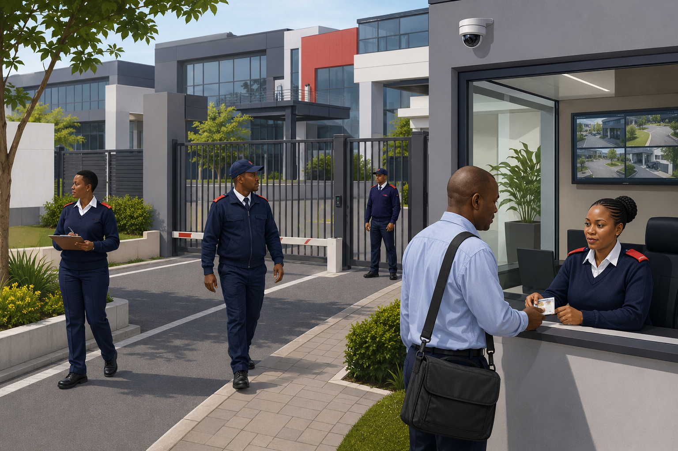
Training focus | Observation, patrol and access control

11.1. AIM OF PATROLLING:
To prevent unauthorised entry into the premises and trace it if it occurs. To prevent irregularities and trace them if they occur.

11.2 SECURITY RISKS
Trespass
Breaking and entering
Armed robbery
Sabotage
Theft
Arson
Fraud
Terrorist attack

11.3 GENERAL PROCEDURE IN AN EMERGENCY
In an emergency, the guard on patrol must raise the alarm using any of the following:
- Portable radio
- Sirens located at different points on the premises
- Whistle
- Emergency telephone

11.4 CIRCUMSTANCES UNDER WHICH THE ALARM SHOULD BE RAISED
Fires
Attempted forced entry
Presence of an unauthorised person or vehicle
Discovery of suspicious articles, incidents or activities
Attempts to interfere with security-protection devices

11.5 EQUIPMENT OF THE GUARD
Baton
Radio
Whistle
Handcuffs
Torch
Firearm in certain circumstances
Dog in certain circumstances

11.6 PHYSICAL BARRIERS
Physical barriers that can be used on the premises include:
- Fence
- Booms
- Doors
- Windows
- Turnstiles
- Safety doors
- Gates
- Burglar proofing
- Counters

11.7 LOCATION OF EMERGENCY EQUIPMENT
They are indicated by safety signs.
The security officer on patrol must identify and establish the location thereof.
Whilst on patrol, the security officer must see to it that the equipment is always accessible.

11.8 PRINCIPLES ON PERFORMING PATROLS
When on patrol, the security officer must make use of cover, illumination, shadow and obstacles to his advantage.
- Make sure that your radio is in working condition.
- Take all your equipment with you.
- Never use a set pattern
- Walk in the shadows and dark spots.
- Report any irregularities.
- Be observant at all times and ready to react.
- Leave your area only when assisting someone.
- Turn back and retrace your route regularly.
- Cover can consist of concrete or brick walls, vehicles, parts of buildings or any other obstacle that keeps you out of sight. The idea is to observe while remaining out of sight.

11.9 CONCEALMENT SITES:
A concealment site is any place on the premises where an intruder can hide or where employees or intruders can hide stolen goods and retrieve them later. The security officer on patrol must identify these sites and pay special attention to them.
Concealment sites can include the following:
- Manholes
- Trenches, drainage pipes
- Open offices, toilets
- Parked vehicles and dark alleys
- Refuse containers
- Empty containers
- Empty unused buildings

11.10 MODULE 8 KNOWLEDGE CHECK AND PRACTICAL ACTIVITY
1. Knowledge question: What is the purpose of a patrol?
2. Application question: Name four locations that require special attention.
3. Scenario activity: During patrol you find an unsecured emergency exit. Explain your actions.
Expected response: assess immediate danger, control access if safe, notify the control point or supervisor, record the condition and follow site instructions.
Completion criterion: the learner's response must be accurate, lawful, site-appropriate and clearly communicated. Record the result in Appendix A.

12. MODULE 9: FIREFIGHTING, PREVENTION AND PROTECTION
AIM The aim of this module is to ensure that you have the necessary knowledge and skills to identify fire hazards, extinguish a fire or raise the alarm in the event of a fire.
Suggested learning time: 120 minutes.

MODULE 9 LEARNING OUTCOMES
After completing this module, the learner should be able to:
- Explain the fire triangle and common classes of fire.
- Select basic fire-extinguisher types for recognised hazards.
- Prioritise alarm, evacuation and personal safety during a fire.
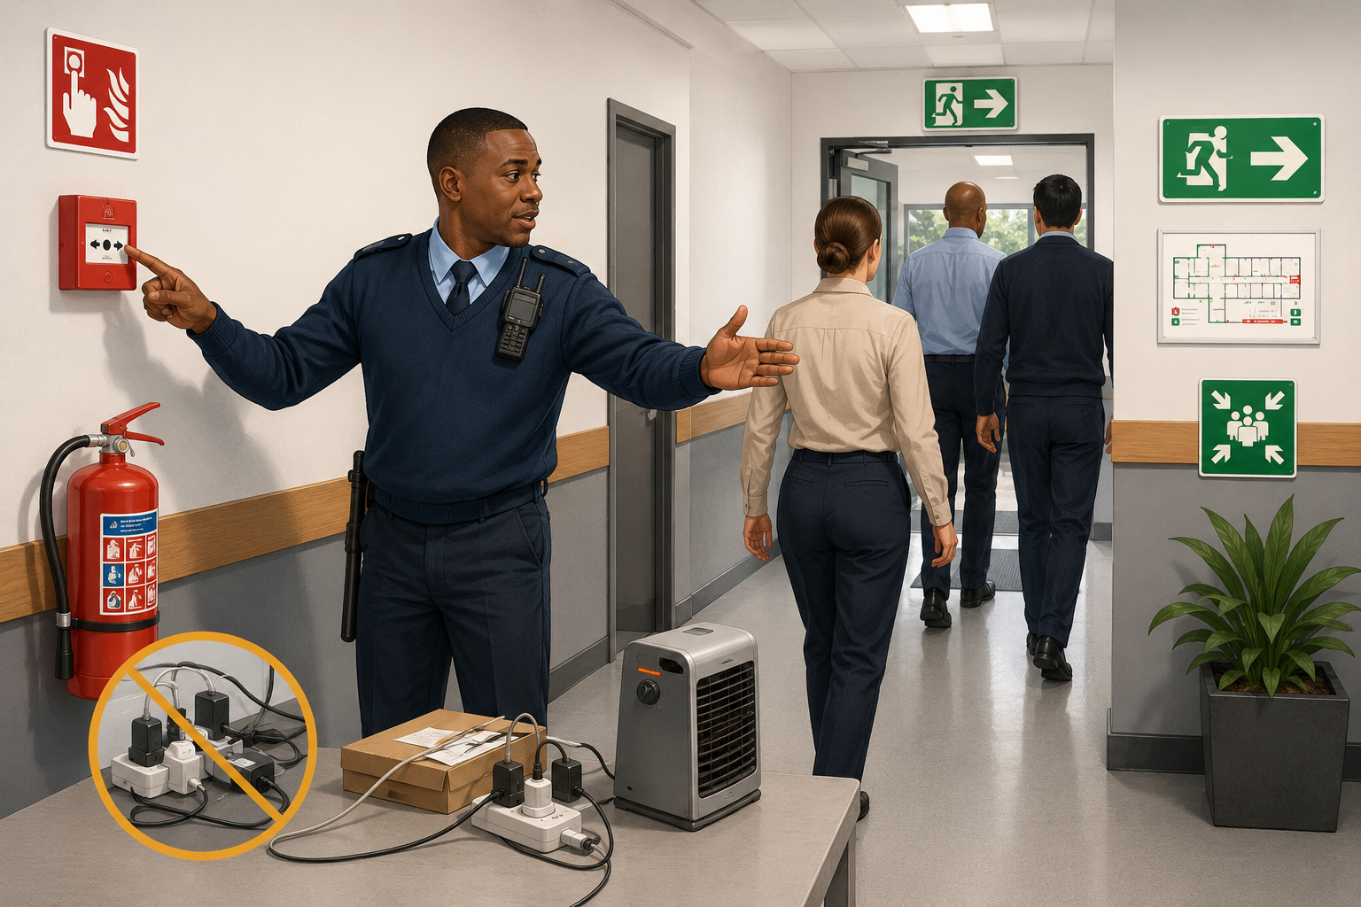
Training focus | Fire prevention and emergency response

12.1 SAFETY PRECAUTIONS BEFORE USING A FIRE EXTINGUISHER
Sabotage and normal wear and tear can cause a fire extinguisher to become a serious danger to the user. Before using a fire extinguisher, do the following:
- Inspect for any damage.
- If it is damaged, do not use it.
- Ensure that it is the correct extinguisher for the fire.
- Ensure that the contents are as stated on the label.
- When activating the extinguisher, kneel next to it with your head turned away.

12.2 LOCATION OF FIREFIGHTING EQUIPMENT AND FIRE ALARMS:
- Extinguisher units should be spread evenly around the premises.
- Immediate accessibility of an extinguisher is important.
- Specific hazards should be identified, and the proper extinguisher should be placed in the immediate vicinity.
- Extinguishers should not be placed too close to the hazardous area.
- Fire alarms should be spread evenly around the premises, especially near hazardous areas.

12.3 ELEMENTS OF FIRE:
All fires involve 3 common elements:
- FUEL: Solids, liquids and gases
- OXYGEN: At an oxygen level of 16%, a fire will continue to burn. Oxygen itself does not burn; it supports and maintains combustion. It is present around fuels and cannot be eliminated.
- HEAT: Heat is probably the element over which the most control can be exercised to prevent fires. Sources of heat include open flames, frictional heat, chemical reactions and mechanical sources such as sparks from grinders.
- CHAIN REACTION: This element is only relevant to firefighting as it is only present during combustion. It is a chemical reaction during which light and heat are involved.

12.4 FIREFIGHTING DOS AND DON'TS
The following are the dos and don'ts: general principles that should be followed when fighting a fire.
DOS
- Ensure that backup assistance is available before tackling a fire.
- Ensure that an escape route is available before committing yourself to tackling the fire.
- Follow the instructions on the extinguisher's label.
- Break the seal and remove the safety device.
- Check the operation of the unit by briefly activating the control mechanism before approaching the fire.
- Apply the extinguishing medium to the base of the flames and move the nozzle rapidly from side to side.
- Drive the flames away from you.
- For vertical fires, start at the base of the flames and move upwards.
- If the fire is outdoors, approach the fire from the windward side.
- When approaching a fire, adopt a crouching posture, which provides protection against heat and smoke.
- Keep alert for any possible changes in fire patterns.
- When tackling a fire involving electrical equipment, isolate the power as soon as possible to prevent reignition.
- Ensure that the fire is completely extinguished and that no sparks remain.
DON’TS:
- Do not place yourself at risk.
- Never tilt or invert any extinguisher during the operation unless it is a turnover type.
- When extinguishing the fire of flammable spillage, never walk on the spillage in case the fire flashes back.
- When tackling a flammable-liquid fire using an extinguisher with a controllable discharge, continue applying the extinguishing medium until the fire is completely extinguished.
- When the fire is extinguished, back off slowly and never turn your back on it.

12.5 ELEMENTARY METHODS OF STARVING A FIRE:
On discovering a fire, you must do everything possible to starve it by removing oxygen and/or combustible material.
- Close all doors and windows.
- Blanket small fires with a bag.
- Throw sand on the fire.
- Turn off the electrical mains.
- Drag combustible articles away or cool them with water.
- Keep bystanders away.
- Clear gates and paths for the fire brigade to enter.

12.6 CLASSIFICATION OF FIRE:
CLASS A FIRES: wood, plastics and textiles.
CLASS B FIRES: Alcohol, benzene, paraffin, and petrol.
CLASS C FIRES: Electrical cables and switchboards.
CLASS D FIRES: Aluminium, magnesium, sodium and potassium.
CLASS E FIRES: Methane, Propane, Butane.

12.7 COMMON FIRE RISKS AND HAZARDS
Fire risks can take various forms and can sometimes be difficult to identify. They can be classified into three major categories:
- PROCESS RISK: hot work, friction, overheating, electrical faults, mechanical sparks, smoking areas, gases.
- STORAGE RISK: This normally exists when people are not present and materials are stored either in transit or in a static location. Examples include chemicals, combustible packing material and compressed gases.

12.8 EXPOSURES:
Exposure is probably the most difficult risk to detect, as it may not exist initially but can develop unnoticed.

12.9 TYPICAL CARELESS ACTIONS:
- Careless smoking habits.
- Thoughtless disposal of matches.
- Use of electrical equipment without caution.
- Leaving electrical switches on.
- Unauthorized fires.
- Electrical appliances left on while not in use.

12.10 IMMEDIATE ACTION DRILLS IN THE EVENT OF FIRE:
- Stay calm.
- Sound an alarm.
- Render first aid to the injured.
- Assist in evacuating all personnel from the area.
- Control the area from a security perspective.
- Shut off the electrical power and gas lines.

12.11 POSSIBLE RESULTING LOSS:
Fire is used throughout industry as a source of energy. Unwanted fires always result in a loss to the owner. Companies spend large sums of money on protection and insurance against fire loss. Fire not only destroys buildings and their contents, but also records, documents and plans. The prevention and control of fire is
therefore as much a part of security as the prevention and detection of crime. Any uncontrolled fire will result in loss, which might take the form of:
- People - lives and injuries
- Property - damage and destruction
- Products - damage and destruction
- Production - delays and complete shutdown

12.12 TYPES OF FIRE EXTINGUISHERS:
- Water extinguisher
- Carbon dioxide extinguisher
- Dry chemical powder extinguisher
- Vaporizing liquid extinguisher
- BCF (BROMOCHLORODIFLOUROMETHANE)

12.13 GOOD HOUSEKEEPING:
Good housekeeping is a valuable aid in the prevention of fires.
- WASTE MATERIALS: Accumulation of waste materials near buildings should not be permitted.
- DEBRIS: Dried grass, debris and brushwood should be cleared away from walls and fences. Roofs should be kept free of dead leaves and other rubbish.
- NO SMOKING: Rigidly enforce 'NO SMOKING' rules in non-smoking areas.
- STORAGE: Stacks should be kept as small as possible, with clear space around each stack.
- BUILDINGS AND FITTINGS: Observe the condition of electrical wiring, including where steam pipes pass near woodwork.

12.14 MODULE 9 KNOWLEDGE CHECK AND PRACTICAL ACTIVITY
1. Knowledge question: Name the elements needed for a fire to continue.
2. Application question: What should happen before attempting to use an extinguisher?
3. Scenario activity: Smoke is visible beyond a closed storeroom door. Explain your priorities.
Expected response: raise the alarm, notify emergency services under the site plan, keep people away, evacuate and use equipment only if trained, safe and an escape route remains available.
Completion criterion: the learner's response must be accurate, lawful, site-appropriate and clearly communicated. Record the result in Appendix A.

13. MODULE 10: RADIO AND TELEPHONE COMMUNICATION
AIM The aim of this module is to ensure that you are able to communicate by radio and telephone and that you can take and deliver messages.
Suggested learning time: 90 minutes.

MODULE 10 LEARNING OUTCOMES
After completing this module, the learner should be able to:
- Use clear telephone and radio-message procedures.
- Apply the radio alphabet and recognised procedure words.
- Care for communications equipment and protect message accuracy.
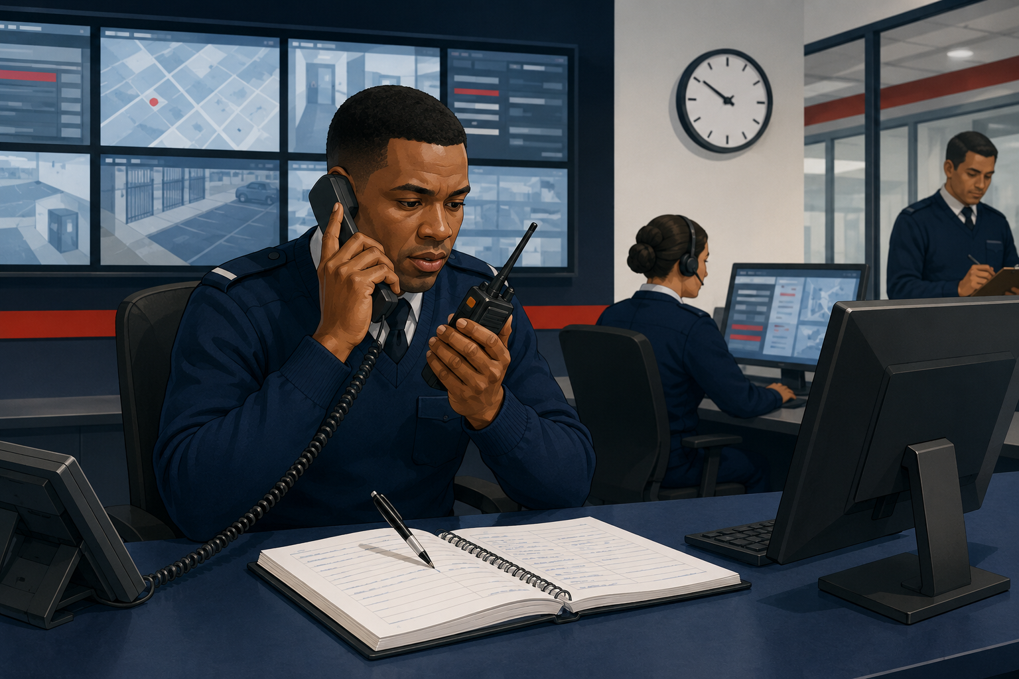
Training focus | Clear communication and accurate record-keeping

13.1 TELEPHONE: PRINCIPLES OF TELEPHONE PROCEDURE:
- DISCIPLINE: It is an important component of effective communication and should be maintained at all times
- VOICE PROCEDURE: Speak clearly and directly into the mouthpiece. Do not eat or smoke while receiving or conveying a message.
- TRANSMISSION OF MESSAGES: Ensure that messages are well thought out, factual and concise.
- SPEED AND ACCURACY: Be concise and accurate when conveying a message.
- TACT: Be tactful, even under the stress of an emergency.
- PATIENCE: Handle all calls with patience and genuine interest.
- COURTESY: Always be courteous with all callers, even your subordinates.
- CONFIDENCE: Handle all calls with confidence.
- INCOMING CALLS: Handle all incoming calls immediately.

13.2 HOW TO RECEIVE AND CONVEY A TELEPHONE MESSAGE:
- Always keep a pen and paper handy.
- Write down the complete message and hand it over to the specific person.
- If you will not see the person, write the message in the information book, occurrence book or message register.

13.3 CARE AND HANDLING OF THE RADIO:
When booking out the radio, check the following:
- ANTENNA/AERIAL
- BATTERY
- ON/OFF SWITCH
- VOLUME
- SQUELCH
- RADIO NUMBER
- CHANNEL

13.4 DOS AND DON'TS
- Carry the radio in its pouch.
- Do not swing it by its aerial.
- Do not leave it in dusty areas or direct sunlight.
- Protect it against rain.
- Do not use abusive language.
- Do not play music in the background.
- Do not discuss classified information over the radio.

13.5 PRINCIPLES OF THE RADIO PROCEDURE
The principles of good voice procedure are defined by the keywords BASS and RSVP, which must be memorised by the radio user.
- B - BRIEF: The message must be brief and contain definite facts.
- A - ACCURATE: The details given must be clear.
- S - SECURITY: Never transmit classified information unless it is disguised.
- S - SPEED: Do not rush the message.
RSVP
- R - RHYTHM: Use short phrases with pauses.
- S - SPEED: Remember that the receiver might wish to note the message.
- V - VOLUME: Speak louder than normal.
- P - PITCH: Pitch the voice slightly higher than normal.
PHONETIC ALPHABETS
- A -- ALPHA B—BRAVO C -- CHARLIE D -- DELTA E - ECHO
- F -- FOXTROT G—GOLF H -- HOTEL I -- INDIA J -- JULIET K – KILO
- L - LIMA M - MIKE N - NOVEMBER O - OSCAR P - PAPA Q - QUEBEC R - ROMEO S - SIERRA T - TANGO U - UNIFORM V - VICTOR W - WHISKEY X - X-RAY Y - YANKEE Z - ZULU

13.6 COMMON WORDS AND PHRASES
- CALL SIGN: The call sign of the station is registered and reflected on the radio licence.
- ABBREVIATED CALL: An unofficial internal call sign arranged by the company.
- OVER: The message is complete, and a reply is expected.
- OUT: The message is complete; do not reply.
- ROGER: I have received and understand your message.
- SITREP: Situation report.
- MAYDAY: Emergency call.
- SAY AGAIN: Repeat your message.
- I SAY AGAIN: I am repeating my previous message.
- RELAY TO: Pass my message to……

13.7 MODULE 10 KNOWLEDGE CHECK AND PRACTICAL ACTIVITY
1. Knowledge question: What information must a complete message contain?
2. Application question: Explain the meaning of SAY AGAIN and ROGER.
3. Scenario activity: Receive and write down a short incident message, then read it back accurately.
Expected response: capture caller/sender, time, location, exact message and required action; confirm unclear information and relay it promptly.
Completion criterion: the learner's response must be accurate, lawful, site-appropriate and clearly communicated. Record the result in Appendix A.

14. MODULE 11: LEGAL ASPECTS
AIM The aim of this module is to define the legal rights of members of the security force with regard to arrest, search and custody within the framework of the law.
Suggested learning time: 180 minutes.

MODULE 11 LEARNING OUTCOMES
After completing this module, the learner should be able to:
- Explain the limits of a private person's arrest powers.
- Apply the principles of necessity and proportionality when considering force.
- Identify current PSiRA registration provisions and post-arrest duties.

14.1 PSIRA REGISTRATION OBLIGATIONS AND REQUIREMENTS (SECTIONS 20-23)
The Private Security Industry Regulation Act 56 of 2001 requires persons who render security services for remuneration, reward, a fee or benefit to be registered as security service providers, subject to the Act's stated exemptions.
- Section 20 sets the obligation to register and requirements applicable to security businesses and relevant managers or directors.
- Section 21 regulates applications and supporting information.
- Section 22 provides for renewal requirements.
- Section 23 sets registration requirements, including fitness and propriety, age, prescribed training and other statutory criteria.
Security personnel must confirm their current registration status and comply with PSiRA directives, the Code of Conduct and employer procedures.

14.2 REGISTRATION ELIGIBILITY AND REFUSAL CONSIDERATIONS (SECTION 23)
Registration decisions are made by PSiRA under the current Act and applicable regulations. A natural-person applicant must satisfy the statutory requirements in section 23, which include being fit and proper, meeting the age and prescribed training requirements, and not being disqualified by specified offences or other statutory restrictions.
A security business must also satisfy the requirements applicable to the business and the relevant persons who manage or control it. Learners must use the latest official PSiRA application requirements rather than relying only on this summary.

14.3 SUSPENSION, WITHDRAWAL AND LAPSING OF REGISTRATION (SECTION 26)
Section 26 permits PSiRA, in the circumstances specified by the Act, to suspend or withdraw registration and provides for registration to lapse when it is not renewed.
- Possible grounds include false application information, material registration irregularities, specified offences, improper conduct, loss of fit-and-proper status or failure to continue meeting registration requirements.
- A suspended security service provider may not render security services unless prior written permission has been obtained from PSiRA.
- Certificates must be returned when registration is suspended, withdrawn or lapses, as required by the Act.

14.4 CRIMINAL PROCEDURE ACT 51/1977
STATE MAY SEIZE CERTAIN ARTICLES SECTION 20:
The State may, in accordance with the provisions of this chapter, seize anything (referred to in this chapter as an article) that is:
- Concerned in the commission of a crime;
- May afford evidence of the commission of a crime; or
- Is intended to be used in the commission of a crime.

14.5 ARREST BY A PRIVATE PERSON WITHOUT A WARRANT (SECTION 42)
A private person may arrest without a warrant only in the circumstances authorised by section 42 of the Criminal Procedure Act 51 of 1977. These include a person who commits or attempts to commit a Schedule 1 offence in the arrestor's presence, or whom the arrestor reasonably suspects of having committed such an offence.
- Other grounds include fresh pursuit by a person believed to have authority to arrest, another law that authorises the arrest, or seeing a person engaged in an affray.
- The owner, lawful occupier or person in charge of property, or an authorised person, may arrest a person found committing an offence on or in respect of that property, subject to section 42.
A security officer must confirm lawful grounds, identify the reason for the arrest, respect constitutional rights and call the police without delay.

14.6 USE OF FORCE IN EFFECTING AN ARREST (SECTION 49)
When a lawful arrest cannot be effected without force because a suspect resists or flees, section 49 permits only force that is reasonably necessary and proportionate in the circumstances.
Deadly force is subject to strict additional conditions. It may be used only where the statutory requirements are met, including a threat of serious violence or specified serious-harm circumstances with no other reasonable means of effecting the arrest.
Security officers must prioritise avoidance, de-escalation, assistance and the minimum lawful force. Every use-of-force incident must be reported and reviewed.

14.7 PROCEDURE AFTER ARREST (SECTION 50)
A person arrested with or without a warrant must be brought to a police station, or another place expressly stated in a warrant, as soon as possible.
- Protect the arrested person's safety, dignity and property.
- Do not punish, threaten or use force beyond what remains lawfully necessary.
- Record the grounds, time, place, force used, witnesses, property and time of handover.
- Hand the person and relevant evidence to the police promptly and obtain handover details.

14.8 SCHEDULE 1 OFFENCES
Schedule 1 to the Criminal Procedure Act lists serious offences relevant to certain arrest and procedural powers. Examples include treason, public violence, murder, culpable homicide, rape and other specified sexual offences, robbery, kidnapping, arson and other offences listed in the current Schedule.
The Schedule has been amended over time. Trainers and learners must consult the current consolidated Criminal Procedure Act before relying on a specific offence classification.

14.9 NATIONAL ROAD TRAFFIC ACT 93 OF 1996: UNAUTHORISED ACTS (SECTION 66)
Without reasonable cause or the consent of the owner, operator or person lawfully in charge, a person may not:
- Sets the machinery thereof in motion.
- Places such a vehicle in gear;
- In any way interferes with the machinery, accessories or parts of such a vehicle; or
- Enters or climbs upon such a vehicle,
A person may also not ride in or drive a vehicle without consent, tamper with or wilfully damage a vehicle, or unlawfully alter identifying numbers. Report suspected unauthorised interference and preserve evidence in accordance with site procedure.

14.10 PROPERTY REMOVAL WITHOUT CONSENT (GENERAL LAW AMENDMENT ACT 50 OF 1956)
Any person who, without any bona fide claim or right and without the consent of the owner or person having control thereof, removes any property from the control of the owner or any other person competent to give such consent, whether or not he intends to return the property to the owner or person from whose control he removed it, shall be guilty of an offence unless it is proved that, at the time of removal, he had
reasonable grounds for believing that the owner or such a person would have consented to such use had they known about it.

14.11 FAILURE TO ACCOUNT FOR SUSPECTED STOLEN GOODS (GENERAL LAW AMENDMENT ACT 62 OF 1955)
Any person who is found in possession of any goods, other than stock or produce, for which there is a reasonable suspicion that they have been stolen, and who is unable to give a satisfactory account of such possession, shall be guilty of an offence and liable on conviction to the penalties that may be imposed for theft.

14.12 CRIMINAL LAW
GROUNDS OF JUSTIFICATION: The requirement of unlawfulness is fulfilled if a person's conduct contravenes a rule of common law, a statutory provision or the legal convictions of society. It should, however, be
pointed out that such conduct may be justified in certain circumstances when grounds regarded as an excuse for performing the act are present.
These grounds for justification are generally based on reasonableness and the public interest. The most important grounds of justification recognised in our law are:
- Private Defense
- Necessity
- Impossibility
- Consent
- Right of chastisement
- Acting upon command
- Official Capacity

14.13 PRIVATE DEFENCE
Private defence is a ground of justification on which a person may rely when protecting their own or another person's interests against an unlawful attack that has commenced or is imminent at the time the interests are protected. This definition makes it clear that there must be both an attack and defensive action against it. Our courts have stipulated certain requirements for each.
THE ATTACK OR THREATENING ATTACK:
- THERE MUST HAVE BEEN SOME KIND OF ATTACK -
- THE ATTACK MUST BE UNLAWFUL
- THE ATTACK MUST BE DIRECTED AT ONE OR OTHER LEGAL INTEREST
- THE ATTACK MUST HAVE COMMENCED
THE DEFENSIVE ACTION:
- IT MUST BE DIRECTED AGAINST THE ATTACKER
- IT MUST BE NECESSARY TO PROTECT THE INTEREST IN DANGER
- THE DEFENSIVE ACTION MUST BE REASONABLE

14.14 CONSENT-BASED SEARCHES
A consent-based search must be lawful, respectful and consistent with site policy. Consent does not replace a statutory power where one is required.
- Consent must be informed, voluntary and specific to the person, property and scope of the search.
- The person giving consent must have capacity and authority to do so.
- Consent may be withdrawn before or during a consent-based search. If it is withdrawn, stop unless another lawful authority clearly applies.
- Respect privacy and dignity. Use an appropriately trained officer and follow gender-sensitive site procedures for personal searches.
- Record the consent, scope, time, participants, any withdrawal and the outcome.

14.15 MODULE 11 KNOWLEDGE CHECK AND PRACTICAL ACTIVITY
1. Knowledge question: When may a private person arrest without a warrant under section 42?
2. Application question: What limits apply to force under section 49?
3. Scenario activity: A suspected shoplifter is detained by authorised staff. Explain the immediate legal safeguards.
Expected response: confirm lawful grounds, use minimum necessary and proportionate force, protect dignity and safety, avoid questioning for a confession, document actions and hand the person to police as soon as possible.
Completion criterion: the learner's response must be accurate, lawful, site-appropriate and clearly communicated. Record the result in Appendix A.

15. MODULE 12: INDUSTRIAL RELATIONS
AIM The aim of this module is to give you basic knowledge of industrial relations, which are of vital importance to the security industry.
Suggested learning time: 60 minutes.

MODULE 12 LEARNING OUTCOMES
After completing this module, the learner should be able to:
- Explain the purpose of disciplinary and grievance procedures.
- Use workplace channels fairly, promptly and without victimisation.
- Distinguish a complaint, grievance and disciplinary matter.

15.1 DISCIPLINARY CODES
Discipline is vital to any organization and is initiated by the management in response to unsatisfactory work performance and behavior.
To help management achieve a sound state of discipline, the company requires a set of rules so that employees are fully aware of what is expected of them. These rules are known as the disciplinary code.
A disciplinary code is not a substitute for management, but it is an expression of the company's policy on discipline.
To minimize disciplinary problems, the rules which the employees are required to keep and the standards which they are expected to maintain must be clearly understood, communicated and accepted.
The main objective of the disciplinary code is to bring an employee back to acceptable standards of performance and behavior and not to punish or get rid of him.

15.2 GRIEVANCE PROCEDURE
It is important that every security officer knows that there are procedures to follow if they are unhappy at work.
A grievance can be defined as any dissatisfaction or feeling of injustice an employee may have in connection with their employment situation.
The grievance procedure gives the security officer a sense of security by providing a formal, step-by-step process for raising complaints.
The objective of the Grievance Procedure is to help parties resolve their grievances in the interest of productivity and stability.
Grievances are best handled at lower levels as quickly as possible.
Unresolved grievances create conflict, so it is important that they are resolved as quickly as possible. Departmental heads must fully appreciate the need for satisfactory employee-employer labour relations and the importance of how they handle employee complaints.

15.3 MODULE 12 KNOWLEDGE CHECK AND PRACTICAL ACTIVITY
1. Knowledge question: What is the purpose of a disciplinary code?
2. Application question: What information should a grievance contain?
3. Scenario activity: A colleague alleges unfair treatment. Describe the correct process.
Expected response: listen without retaliation, record the concern, use the approved grievance channel, maintain confidentiality and allow a fair response.
Completion criterion: the learner's response must be accurate, lawful, site-appropriate and clearly communicated. Record the result in Appendix A.

16. MODULE 13: OCCUPATIONAL SAFETY
AIM At the end of this module, the student will have a basic understanding of the causes of accidents and the steps to take to prevent them.
Suggested learning time: 90 minutes.

MODULE 13 LEARNING OUTCOMES
After completing this module, the learner should be able to:
- Recognise safety signs, hazards, unsafe acts and unsafe conditions.
- Apply basic housekeeping and incident-reporting practices.
- Take appropriate action when a workplace hazard is identified.

16.1 SYMBOLIC SAFETY SIGNS:
Symbolic safety signs consist of 3 parts:
- Shape
- Colour
- Pictogram
- Safety signs are divided into five categories, each with a different colour and pictogram.
- GENERAL INFORMATION: Square-shaped with a green background and a white pictogram, this category of signs provides general information about the premises, for example, emergency exits and first aid.
- FIRE INFORMATION: Square-shaped with a white background, red border and red pictogram. It gives information about the location and type of firefighting equipment on the premises.
- WARNING INFORMATION: Triangular, with a yellow background, black border and black pictogram. These signs warn of dangerous situations that might be present on the premises.
- PROHIBITORY: Circular, with a white background, red border and red pictogram.
- MANDATORY: Circular, with a blue background and white pictogram. These signs deal mainly with protective clothing. They are legally binding and must be obeyed.

16.2 DANGERS OF SMOKING IN A NON-SMOKING ZONE
A non-smoking area is normally designated where flammable liquids or highly combustible materials are stored. Smoking in such an area might result in loss of life, loss of or damage to property, and loss or waste of production time.
DEFINITION OF AN ACCIDENT: An accident can be defined as an undesirable event often caused by unsafe acts and conditions. It can damage property and injure personnel.
- Accidents are the result of a lack of control.
- Accidents don’t just happen.
- An accident may be the direct result of a person acting in an unsafe manner.
- An accident may also result from an unsafe condition that has been left unattended.

16.3 CAUSES OF AN ACCIDENT:
- Lack of knowledge
- Physical or mental defect
- Inadequate work standard
- Improper attitude
- Unsafe condition

16.4 UNSAFE ACTS
- An unsafe act occurs when a worker works improperly or fails to adhere to the established standards.
- Working at an unsafe speed - for example, driving a forklift at high speed inside the workshop.
- Failure to secure machinery and material.
- Rendering safety devices inoperative.
- Arranging items in an unsafe manner.
- Fooling, teasing and abuse.

16.5 UNSAFE CONDITIONS
An unsafe condition can be defined as any condition that has the potential to cause an accident:
- Unsafe construction.
- Lack of guards.
- Uneven or slippery floors.
- Poorly lit up areas.
- Unsafe storage of hazardous substances.
- Committing unsafe acts.
- Creating unsafe conditions.

16.6 EXAMPLES OF UNSAFE ACTS AND CONDITIONS WHEN LOADING OR OFFLOADING A TRUCK:
- Poorly lit up areas.
- Loads falling from the forklift.
- Uneven or slippery floors.
- Uneven loads.

16.7 EXAMPLES OF POOR HOUSEKEEPING
- Poorly lit up areas.
- Uneven or slippery floors.
- Unsafe arrangement and placement of material.
- Unhealthy gases.
- Irregular removal of refuse.
- Dirty, unpainted buildings.

16.8 REPORT UNSAFE ACTS AND CONDITIONS
- Report to a supervisor.
- If no supervisor is present, make an entry in the occurrence book.
- Make sure that the entry has been brought to management's attention.

16.9 MODULE 13 KNOWLEDGE CHECK AND PRACTICAL ACTIVITY
1. Knowledge question: Distinguish an unsafe act from an unsafe condition.
2. Application question: What should a hazard report contain?
3. Scenario activity: You find a blocked fire exit during patrol. Explain your actions.
Expected response: protect people from immediate risk, report and escalate promptly, arrange correction if authorised, record the condition and verify follow-up.
Completion criterion: the learner's response must be accurate, lawful, site-appropriate and clearly communicated. Record the result in Appendix A.

17. MODULE 14: ACCESS CONTROL
AIM The aim of this module is to enable the security personnel to understand the reasons for, and to apply access control effectively.
Suggested learning time: 120 minutes.

MODULE 14 LEARNING OUTCOMES
After completing this module, the learner should be able to:
- Explain the purpose and functions of access control.
- Apply visitor, employee, vehicle and property-control procedures.
- Use detection, denial and deterrence principles consistently.

17.1 DEFINITION OF ACCESS CONTROL:
Access control is the application of systems or methods to control the access, entry or passage of people, vehicles and parcels into and out of the premises.

17.2 REASONS FOR ACCESS CONTROL:
- Who has access, and to which areas?
- Egress procedures
- How are they identified?
- How are they monitored during their period of duty?
- Observe all orders relating to access control.

17.3 FUNCTIONS AT ACCESS CONTROL
- Supervising the entry and exit of all regular employees
- Regulating all parcels entering or leaving the premises
- Controlling all visitors or contractors entering the premises
- Issuing permits to authorise visitors and contractors
- Keeping a visitors' logbook
- Conducting searches
- Maintaining records of all vehicles entering or leaving the premises.

17.4 THE 3 “D” PRINCIPLE
Access control is based on the 3 “D” principle: DENIAL, DETECTION AND DETERRANCE.
- DENIAL: This is the first line of defence and includes all the measures and aids that prevent an unauthorised person from entering the premises. These include gates, guards and fences.
- DETECTION: If an intruder succeeds in breaking through the first line of defence, the intruder must be discovered, apprehended and removed before having an opportunity to commit a crime. The following aids are used: guards, alarms, dogs and CCTV.
- DETERRENCE: The more barriers an intruder encounters, the lower the chances of achieving the intended aim. Quite often, a psychological deterrent is enough to turn an intruder away. The following can be used: fences, alarms, gates and dogs.

17.5 SECURITY KNOWLEDGE
The security officer must have proper knowledge of the following to enforce access control adequately:
- Utilizing available aids
- Task description
- Legal aspects
- Permits and waybills
- Immediate action drills
- One official language
- Powers of observation
- Behavioural patterns
- Access and egress procedures
- Emergency procedures

17.6 AIDS EFFECTIVE IN ACCESS CONTROL
The following aids can be used in access control:
- Fence
- Alarms
- Lights
- Burglar proofing
- Locks
- Electronic gates/booms
- Guards
- Dogs
- Strong rooms
- Safes and CCTV

17.7 ACCESS CONTROL PROCEDURES
When performing access control, keep in mind that you are probably the first person visitors meet at the company. As a visitor may not want to waste time, you must help them reach their appointment as soon as possible. Follow these procedures when a visitor arrives:
- Greeting the visitor
- Ask whether you can assist the visitor
- Ask the visitor to identify themselves
- Determine whom the visitor wants to see and which department they want to visit
- Determine whether the visitor has an appointment
- Determine whether the visitor has a firearm to declare
- Issue a receipt and secure the firearm in a safe
- Issue a permit and arrange an escort
- Thank the visitor for their time
WHEN LEAVING:
- Take the permit back
- Return the firearm
- Record the time of departure
- Ask whether the visitor has any company property to declare
- Wish the visitor a safe journey

17.8 MODULE 14 KNOWLEDGE CHECK AND PRACTICAL ACTIVITY
1. Knowledge question: State the main purposes of access control.
2. Application question: Explain detection, denial and deterrence.
3. Scenario activity: A visitor refuses identification but demands entry. Explain your response.
Expected response: remain courteous, deny entry under site rules, contact the host or supervisor, avoid argument and record the refusal and outcome.
Completion criterion: the learner's response must be accurate, lawful, site-appropriate and clearly communicated. Record the result in Appendix A.

18. MODULE 15: SEARCH PROCEDURES AND TECHNIQUES
AIM The aim of this module is to ensure that you will be able to search persons, vehicles and containers thoroughly in terms of the Criminal Procedure Act.
Suggested learning time: 120 minutes.

MODULE 15 LEARNING OUTCOMES
After completing this module, the learner should be able to:
- Conduct consent-based searches respectfully and systematically.
- Identify common concealment areas without damaging property.
- Record refusals, discoveries and escalation actions correctly.
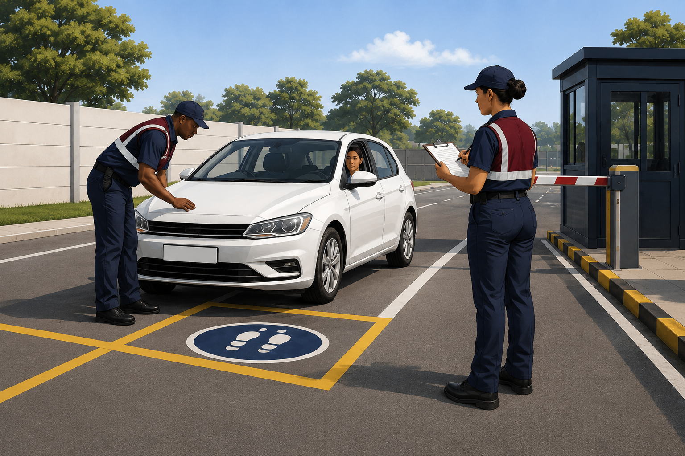
Training focus | Safe, respectful search procedures

18.1 THE GOLDEN RULE OF SEARCHING:
- Identify the person.
- Search systematically and thoroughly.
- Put yourself in the position of the person being searched and consider where you would hide an item.
- Be alert against any possible attack during the search.
- The search must always be conducted within the bounds of the Criminal Procedure Act.

18.2 WHAT TO LOOK FOR DURING THE SEARCH:
- Suspicious objects
- Weapons
- Prohibited habit-forming drugs and/or liquor.
- Precious metals
- Stolen property

18.3 SEARCHING THE VEHICLE
Determine whether the vehicle may enter or leave the premises. Searching a motor vehicle takes time, and vehicle searches are normally conducted superficially. The time required to search a vehicle thoroughly cannot be justified unless there are good reasons to do so. A vehicle has many hiding places, but most concealed items can be found if the search is conducted systematically and thoroughly. PROCEDURE TO BE FOLLOWED:
- The people in the vehicle must be informed that they and the vehicle are liable to be searched.
- All people should be told to get out of the vehicle.
- One security officer should conduct the search while a second security officer stands back and supervises.
- He will inform the searcher which other places still need to be searched.
- If a person refuses to be searched or to have their vehicle searched, they will be denied access to the premises.
SEARCHING THE PASSENGER COMPARTMENT:
- Dashboard compartments and cubbyholes
- Behind dashboard
- Check the weight of doors
- Wind down the windows
- Lift movable mats
- Check under the seats
- Check all seats
- Rear window panel shelf

18.4 PLACES TO SEARCH:
COMMERCIAL VEHICLE:
- Between twin rear wheels
- Packing sacks and containers
- Driver's cab
- All along the chassis
- On the inside of the spare wheel
- Hidden against tailboard of the loaded vehicle
- Look for false bottoms in vehicles with wooden bodies
MOTORCYCLES:
- Petrol tank
- Toolbox or case
- Rubber handle grips
- Footrest
- Lamp
- Mudguards and all tubular framework
BICYCLES:
- Handlebars and rubber grips
- Bell and bicycle pumps
- Lamps and dynamos
- The saddle
- All tubular framework
- Sacks and tool bags

18.5 PROCEDURES IN DOING ROUTINE CHECKS:
- Obtain permission to search
- Request the person to stand with his legs apart and arms raised
- Run hands quickly but thoroughly over the person’s body from head to toe.
- Clothing should be rolled between fingers to discover even smaller objects.
- If the person is a suspect, have them stand facing a wall or vehicle with their hands on the structure.
Routine checks normally include checking ID documents. The following should be checked:
- PHOTOGRAPH - Compare the photograph in the document with the holder. If the person is wearing a hat, ask them to remove it.
- STAMP - Carefully examine the stamp to ensure that it is genuine and original.
- CONDITION OF THE DOCUMENT - Check the date of issue against the condition of the document. There should be a reason to suspect a new document in poor condition, and vice versa.

18.6 PROCEDURE FOR SELECTING COMPANY EMPLOYEES TO BE SEARCHED:
The selection of company employees for searching can be done electronically or manually. Some companies use a computer programmed to select people as they pass through turnstiles or doors. Others use coloured cards or balls drawn by employees. Keep the following in mind when selecting an employee to be searched:
- Don’t discriminate against race, religion or sex
- Don’t select the same person every day
- Stay friendly
- Don’t make jokes about it.

18.7 AREAS TO BE COVERED DURING SEARCHING:
When searching a person, cover the following areas: under the arms, the stomach, the inside of the thighs and the crotch, trouser turn-ups, seams of padded areas, overalls and clothing held in the hands. Headgear, including hats, should be removed and searched.

18.8 SEARCHING OF BRIEFCASE, PARCELS OR CONTAINERS:
When searching a briefcase or parcel:
- Do not damage anything
- Obtain permission before searching
- Ask the owner to open their own briefcase or parcel
- Check for false bottoms or compartments
- If there is anything suspicious, report it to the supervisor.

18.9 MODULE 15 KNOWLEDGE CHECK AND PRACTICAL ACTIVITY
1. Knowledge question: What makes consent to a search valid?
2. Application question: What should happen if consent is withdrawn?
3. Scenario activity: A person agrees to a bag search but then withdraws consent. Explain your response.
Expected response: stop the consent-based search unless another lawful authority applies, deny or manage access under site policy, call a supervisor and document the event.
Completion criterion: the learner's response must be accurate, lawful, site-appropriate and clearly communicated. Record the result in Appendix A.

19. MODULE 16: POCKETBOOKS AND THE OCCURRENCE BOOK
AIM The aim of this module is to ensure that the security officer understands the importance of a pocket book and the correct way to keep it.
Suggested learning time: 90 minutes.

MODULE 16 LEARNING OUTCOMES
After completing this module, the learner should be able to:
- Maintain a pocketbook and occurrence-book entry accurately.
- Record events contemporaneously, objectively and permanently.
- Explain how security records may support investigations and court evidence.

19.1 REASONS FOR KEEPING THE POCKET BOOK
- To provide a permanent personal record of hours on duty and work performance.
- To record messages, instructions and incidents during duty.
- To record details of the property found.
- To record details of fires, accidents, enquiries, suspicious people and vehicles, and information that will assist during investigations.
- To record all arrests made.
- To record all irregularities.

19.2 AS EVIDENCE IN COURT:
- To be used as evidence in court.
- To recall the details of a case for use in court.
- To recall the details of arrests and investigations for use in court.
- To record information that assists in an investigation.

19.3 REQUIREMENTS FOR KEEPING THE POCKET BOOK:
The information written into the pocketbook must answer the following questions: WHAT, WHO, WHEN, WHERE, WHY AND HOW.
- The pocketbook must always be kept neat and clean.
- It is an official document, and no pages may be torn out.
- No entries should be erased or altered.
- All entries must be made with a pen.

19.4 MODULE 16 KNOWLEDGE CHECK AND PRACTICAL ACTIVITY
1. Knowledge question: Why must entries be made promptly and in ink?
2. Application question: What information belongs in an occurrence-book entry?
3. Scenario activity: Write an objective entry for a broken perimeter light reported at 22:15.
Expected response: record date, exact time, place, observation, persons notified, action taken and outcome; avoid erasures, speculation and unexplained abbreviations.
Completion criterion: the learner's response must be accurate, lawful, site-appropriate and clearly communicated. Record the result in Appendix A.

20. MODULE 17: WRITTEN REPORTS
AIM The aim of this module is to provide students with guidelines for effective report writing.
Suggested learning time: 90 minutes.

MODULE 17 LEARNING OUTCOMES
After completing this module, the learner should be able to:
- Write accurate, concise, complete and objective reports.
- Organise report information using who, what, when, where, why and how.
- Review a report for clarity, chronology and unsupported opinion.

20.1 REQUIREMENTS FOR AN EFFECTIVE REPORT:
- Accurate
- Concise
- Complete
- Objective
- Descriptive
- Honest

20.2 CONTENT OF THE REPORT:
- Who
- What
- When
- Where
- Why
- How

20.3 FORM OF THE REPORT:
HEADING:
- Start on the left side, below the addresses, using capital letters.
- Do not underline the heading or use a full stop.
- It is a concise summary of the contents and must provide sufficient information.
Requirements:
- It must contain the subject.
- Date and place of occurrence.
- Time or period.
- People involved.
BODY:
- One line must be left blank below the heading.
- Paragraphs must be in block form.
- Paragraphs must continuously be numbered up to the end.
- When different subjects are addressed, use subheadings.
- The contents must be written concisely in the first person.
- Facts should be recorded in chronological order.
COMMENT:
- Information that may be relevant but cannot be stated as a fact can be conveyed under this heading.
- This can also be used by the writer to give an opinion or draw attention to their own deductions.
RECOMMENDATION:
- In almost every report it is necessary for the reporter to make a recommendation.
- It must not be done in such a way that it can be seen as an instruction.
CONCLUSION:
- The report is concluded with the writer’s signature on the left-hand side.
- The writer's initials and surname must be typed under the signature, with the designated post indicated below in CAPITAL LETTERS.

20.4 MODULE 17 KNOWLEDGE CHECK AND PRACTICAL ACTIVITY
1. Knowledge question: Name five qualities of an effective report.
2. Application question: What questions structure a complete incident report?
3. Scenario activity: Draft a short chronological report from facilitator-provided facts.
Expected response: the report is accurate, concise, complete, objective, chronological and clear about who, what, when, where, why and how.
Completion criterion: the learner's response must be accurate, lawful, site-appropriate and clearly communicated. Record the result in Appendix A.

21. MODULE 18: THE THREAT
AIM The aim of this module is to ensure that the student knows the threats that he and the installation are exposed to.
Suggested learning time: 90 minutes.

MODULE 18 LEARNING OUTCOMES
After completing this module, the learner should be able to:
- Differentiate internal and external threats.
- Identify threats to personnel, information, property and operations.
- Recommend practical countermeasures and reporting actions.

21.1 DEFINITION OF THE THREAT:
A threat can be defined as any action or occurrence that is detrimental to an organisation or person and can differ in intensity depending on TIME, PLACE AND PRODUCT.
As mentioned in the definition, a threat can be influenced by:
- LOCATION - If the company is situated in an area where housebreaking occurs frequently, there is a good chance that it will happen.
- TIME - The specific period also has an influence. For instance, during a time of financial instability, with a high percentage of people out of work, offences for financial gain will increase.
- PRODUCT - The product or service rendered plays an important role. In a company manufacturing armaments, espionage and sabotage will be the main threats, whereas a financial institution must have measures against fraud and robbery.

21.2 TYPES OF THREATS
The threat can always be divided into INTERNAL and EXTERNAL threats.

21.3 INTERNAL THREATS:
These are threats arising from people authorised to be on the company's premises. This includes members of management, employees, contractors and people making deliveries. Internal threats include the following:
- Espionage
- Breaking and entering
- Theft
- Fraud
- Sabotage
- Strikes

21.4 EXTERNAL THREATS:
External threats arise from people who are not authorised to be on the company's premises or from visitors using the services rendered by the company. They can include the following:
- Espionage
- Sabotage
- Breaking and entering
- Theft
- Fraud
- Robbery

21.5 INTERNAL AND EXTERNAL THREATS:
People employed by, or contracted to, the company may help unauthorised people commit crimes by supplying information about the company's security measures and the dates and locations of deliveries.

21.6 THREATS AGAINST SECURITY OFFICERS
- Assault
- Robbery
- Murder
- Intimidation
- Bribery

21.7 THREATS AGAINST INSTALLATION
Most installations are exposed to the following threats, depending on the services they render or the products they produce or sell:
- Industrial espionage
- Breaking and entering
- Robbery
- Sabotage
- Trespass
- Arson
- Theft
- Malicious damage to property
- Vehicle hijacking
- Fraud

21.8 COUNTERMEASURES AGAINST THREATS:
- Observe and report suspicious objects, parcels, people and vehicles.
- Enforce all security measures prescribed by the organization.
- Identify and report all loopholes to the owner or your supervisor.
- Do not discuss security measures or work with unauthorised people.
- Report any form of intimidation or bribery immediately to your supervisor.
- Avoid large groups of people, and do not try to apprehend a suspect in such a group. Get backup.
- Be alert if unknown people approach you. Do not trust anybody, and keep a safe distance.
- Know how to use your firearm and other equipment.
- Know the telephone numbers of the emergency services and the nearest police station.
- Know and understand your legal rights.
When escorting the vehicle:
- Plan your route beforehand.
- Do not allow unauthorised people into the vehicle.
- If in radio contact, report all suspicious people or vehicles.
- Turn away from large groups.
- Don’t discuss your load or route with unauthorized people.

21.9 MODULE 18 KNOWLEDGE CHECK AND PRACTICAL ACTIVITY
1. Knowledge question: Differentiate an internal threat from an external threat.
2. Application question: Name four possible countermeasures.
3. Scenario activity: An employee shares restricted information with an unauthorised person. Explain the response.
Expected response: protect information, preserve evidence, report through authorised channels, limit further disclosure and avoid confronting or accusing beyond assigned authority.
Completion criterion: the learner's response must be accurate, lawful, site-appropriate and clearly communicated. Record the result in Appendix A.

APPENDIX A: KNOWLEDGE-CHECK RECORD
Use this record for printed delivery or transfer the same fields to the learning-management system.
Module | Attempt date | Score | Result | Facilitator / online verification
1
2
3
4
5
6
7
8
9
10
11
12
13
14
15
16
17
18

APPENDIX B: GLOSSARY
Access control: Measures used to regulate and record entry to, exit from or movement within premises.
Bomb threat: A communication claiming or suggesting that an explosive device has been or will be used.
Client representative: A person authorised to act for the organisation receiving security services.
De-escalation: Communication and positioning intended to reduce tension and prevent violence.
Deterrence: Measures that discourage unauthorised or harmful conduct.
Occurrence book: An official chronological record of events, reports and actions at a security site.
Patrol: A systematic inspection of an assigned area to detect risks, irregularities or incidents.
Pocketbook: A security officer's contemporaneous personal record of duties, observations and actions.
Proportionate: Appropriate in degree to the lawful purpose and the risk faced.
Risk: The possibility that a hazard or threat will cause harm, loss or disruption.
Suspicious object: An unattended or unusual item whose location, appearance or circumstances require caution and escalation.
Threat: A person, act, condition or event with the potential to cause harm or loss.
Vital point: An asset, location or system whose loss or disruption would seriously affect operations.
Vulnerable area: A location or feature that is relatively exposed to unauthorised access, damage or attack.

APPENDIX C: REFERENCES AND VERSION CONTROL

Primary references
- Private Security Industry Regulation Act 56 of 2001
- Criminal Procedure Act 51 of 1977 (consolidated source)
- National Road Traffic Act 93 of 1996
- PSiRA circular: Standardising Training Curriculum, 29 June 2021
Legislation and regulatory requirements change. Before each course intake, the training provider must verify the latest official requirements, amendments, directives and assessment rules.

Revision record
Edition 2.1 | 18 August 2026 | Converted suitable learning outcomes, requirements, examples, procedures, equipment lists and safety guidance into structured bullet points for improved print and online readability.
Edition 2.0 | 18 August 2026 | Added learner guidance, learning outcomes, missing modules, section 7.7, knowledge checks, glossary, completion records, current legal references and improved print/online navigation.

APPENDIX D: LEARNER COMPLETION AND SIGN-OFF
Complete this page for printed delivery. For online delivery, capture the same information in the learning-management system.
Learner information | Details
Learner full name
Identity / learner number
Course dates
Final knowledge result
Practical assessment result
Facilitator / assessor
Learner declaration: I confirm that I completed the assigned learning and assessment activities and that the information recorded above is accurate.
Learner signature: ______________________________ Date: __________________
Facilitator / assessor signature: __________________ Date: __________________

